Movie Review Generator - Paper

Project Description

The Movie Review Generator is a project designed to help people decide if a movie, show, or other media is worth their time or money. It uses natural language processing (NLP) to collect and analyze reviews. The app works by gathering reviews from IMDB’s database, and these reviews are then analyzed with NLP to determine whether the tone of the review is positive, neutral, or negative. After analyzing all the reviews, the app calculates an overall score to give users a clear answer to the question: Is this piece of media worth it?

Logs of Progress

The development of the Movie Review Generator involved contributions from team members Tomasz Grzesik, Karan Sharma, Andrew Meier, and Kabir Kamboj. Below is a summary of progress made on key tasks throughout the project:

* README File:

Status: Created

Responsible Member(s): Karan Sharma, Tomasz Grzesik

* Flask Setup:

Status: Done

Responsible Member(s): Entire Team

* Web Scraping:

Status: Attempted

Responsible Member(s): Karan Sharma

* Lexicographic and Dataset Approach:

Status: Working

Responsible Member(s): Karan Sharma, Andrew Meier

* Frontend:

Status: Done

Responsible Member(s): Andrew Meier

* Backend:

Status: Done

Responsible Member(s): Entire Team

* Images Subfolder:

Status: Partially Done

Responsible Member(s): Entire Team

* Demo Video:

Status: Done

Responsible Member(s): Karan Sharma, Tomasz Grzesik

* References:

Status: Done

Responsible Member(s): Tomasz Grzesik

Demo Video

[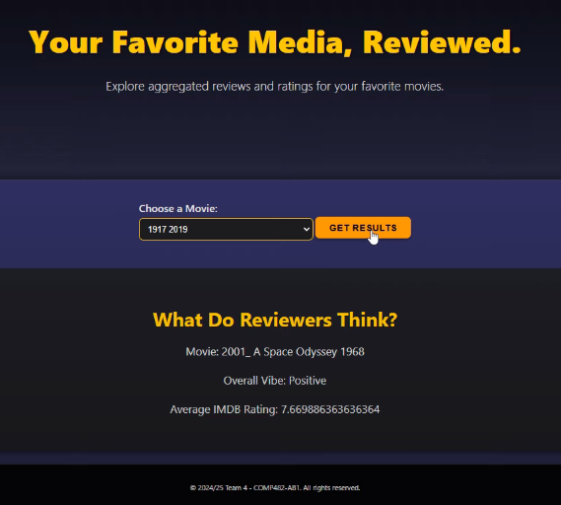](https://youtu.be/yJOTjSKP2Xo)

<https://youtu.be/yJOTjSKP2Xo>

References

Pal, Aditya. “IMDB Movie Reviews Dataset.” IEEE DataPort, IEEE, 10 Dec. 2020, [ieee-dataport.org/open-access/imdb-movie-reviews-dataset](http://ieee-dataport.org/open-access/imdb-movie-reviews-dataset)

“Python: Sentiment Analysis Using Vader.” GeeksforGeeks, GeeksforGeeks, 7 Oct. 2021, [www.geeksforgeeks.org/python-sentiment-analysis-using-vader/](http://www.geeksforgeeks.org/python-sentiment-analysis-using-vader/)

“Welcome to Vadersentiment’s Documentation!¶.” VaderSentiment 3.3.1 Documentation, VaderSentiment, [vadersentiment.readthedocs.io/en/latest/](http://vadersentiment.readthedocs.io/en/latest/) Accessed 26 Nov. 2024

Brownlee, Jason. Deep Learning for Natural Language Processing. Machine Learning Mastery, 2019.

Scrapy Documentation. Scrapy 2.9.0 Documentation. Available at: <https://docs.scrapy.org/>

Flask Documentation. Flask: A Web Framework for Python. Available at: <https://flask.palletsprojects.com/>

TextBlob Documentation. TextBlob: Simplified Text Processing. Available at: <https://textblob.readthedocs.io/>

Google Cloud APIs. Natural Language API. Available at: <https://cloud.google.com/natural-language/>

YouTube. Demo Videos. Available at: <https://www.youtube.com>